Export pipeline and import pipeline, event base trigger, system authentication

I Need to export pipeline form development to production
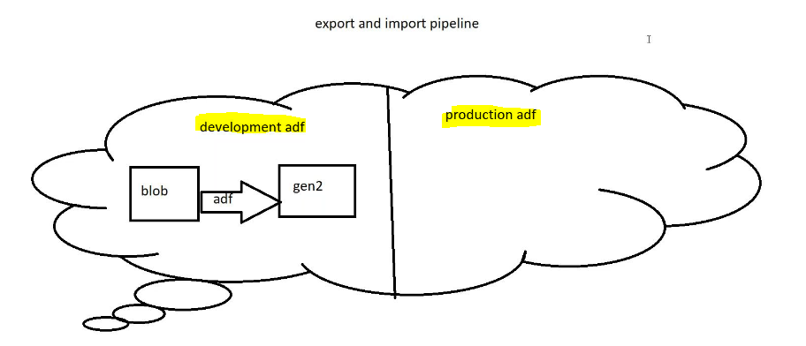
Create blob storage:
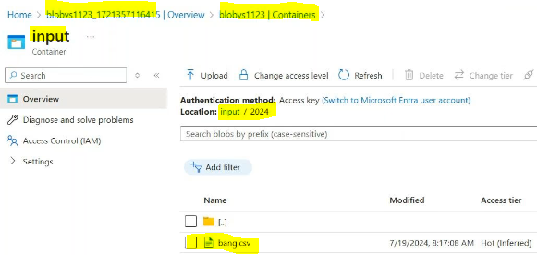
Create gen2 storage:
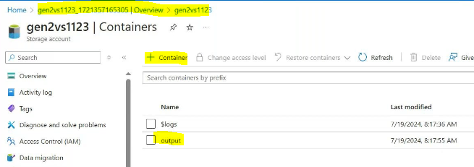
Create 2 Data factories 1 is for development 1 is for production
In development adf
Create linked services:
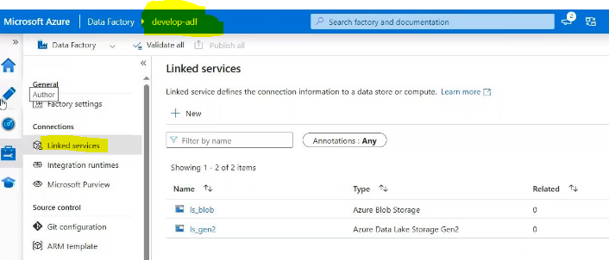
Create data set for source side:
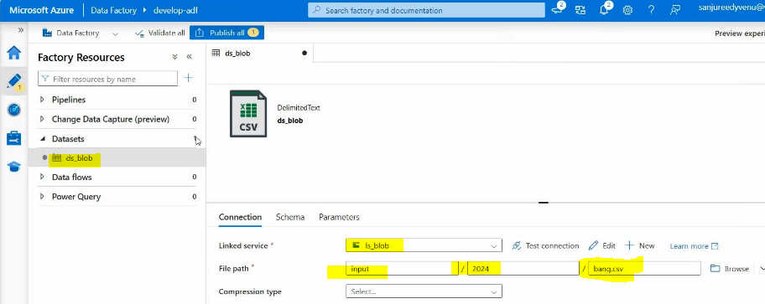
Create data set for source side:
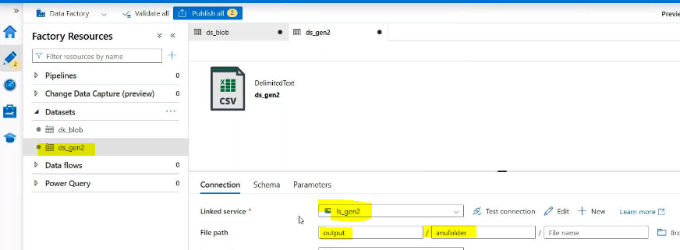

Create pipeline:copy data activityadd source side blob dataset
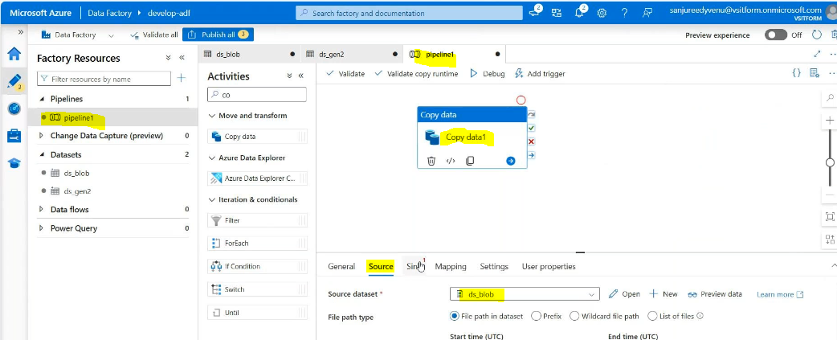
Sink side:
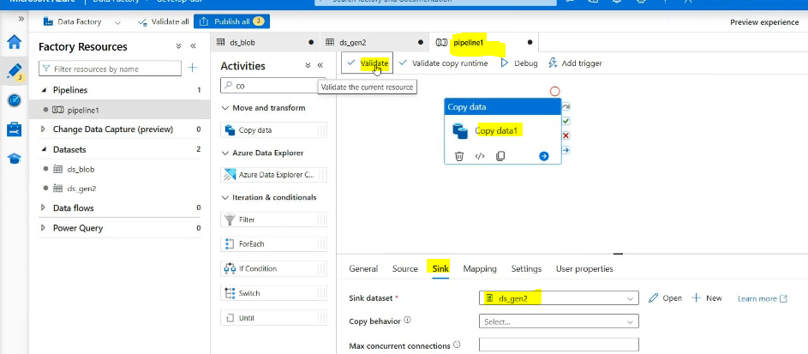
Validate & debug
Result:
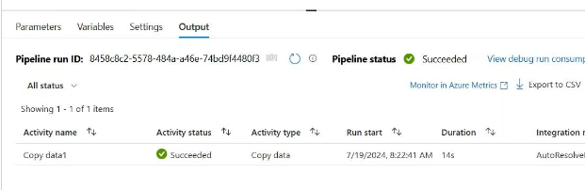
Then publish the pipeline:
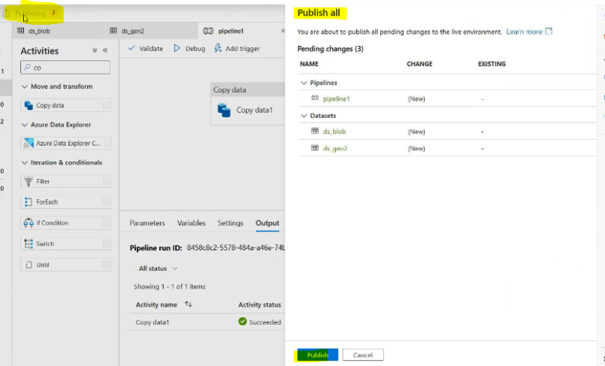

Export the pipeline
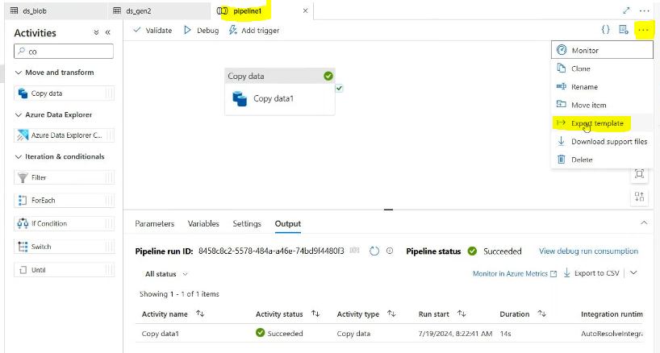
One zip file will downloaded
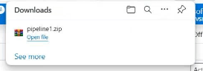
Extract files
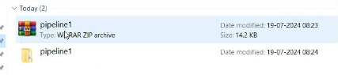
then go to production adf
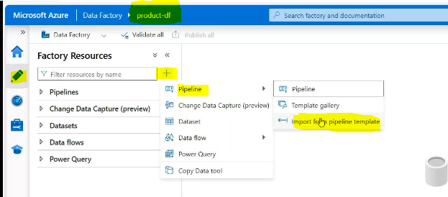
Then upload the zip file whatever we are downloaded
Then create linked services blob side and gen to side as it is
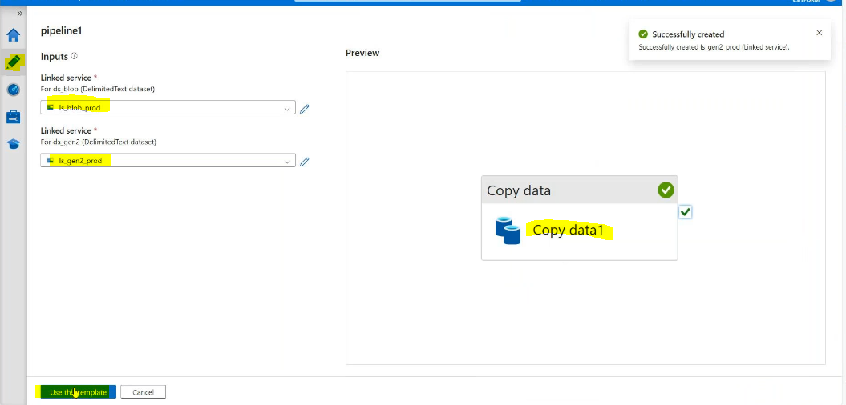
Dataset it will inbuilt source side and sink side :
Other wise we need to create it
Source side:
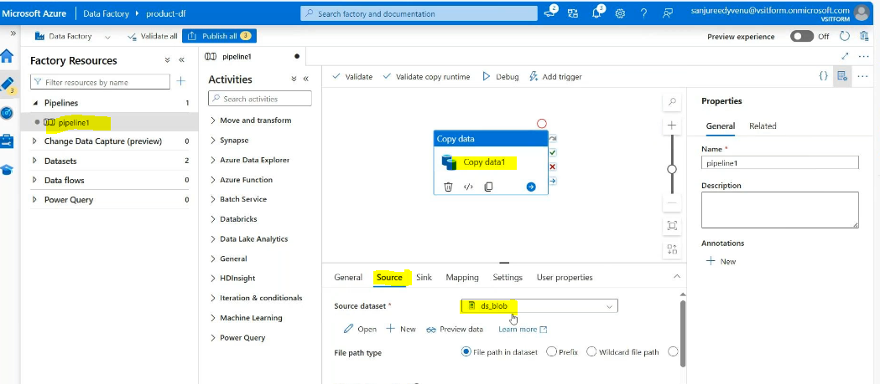
Sink side:
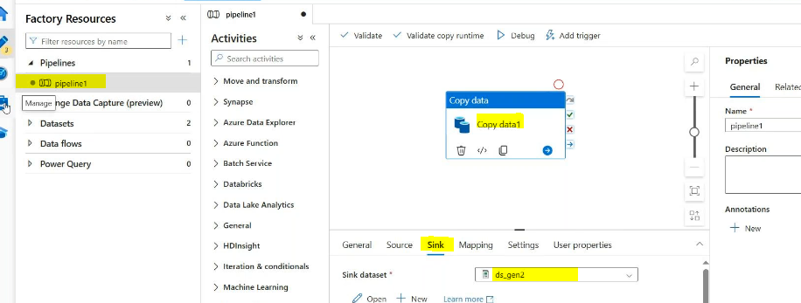
Validate & debug
Result:
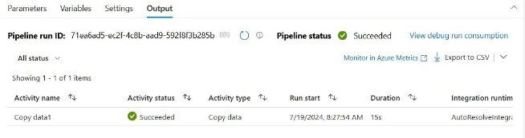
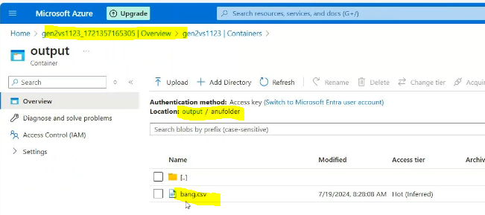

Event based trigger in developementadf environment
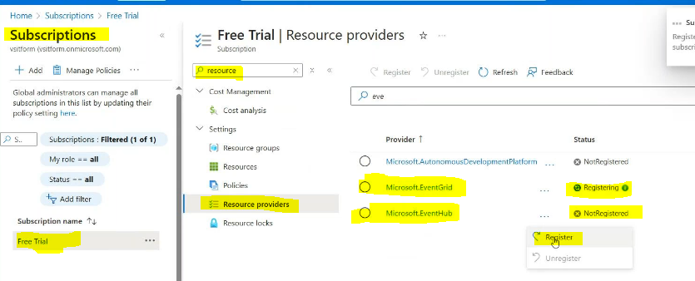
Both we need to register like this
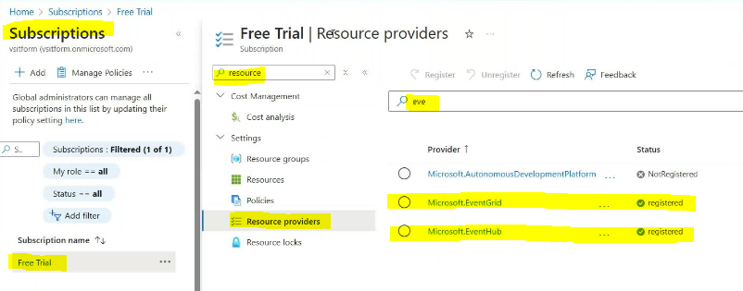
Then create a triggers
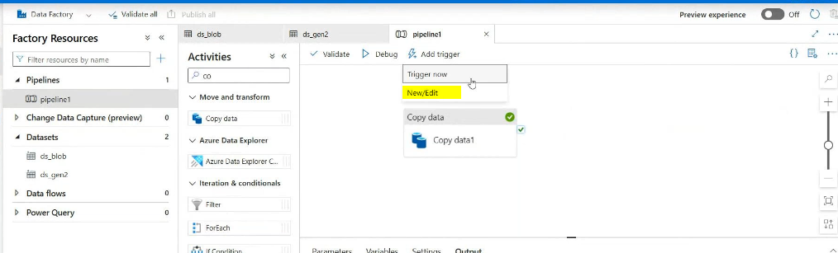
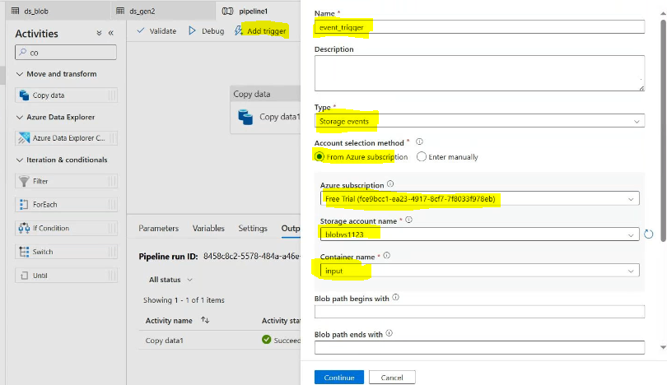
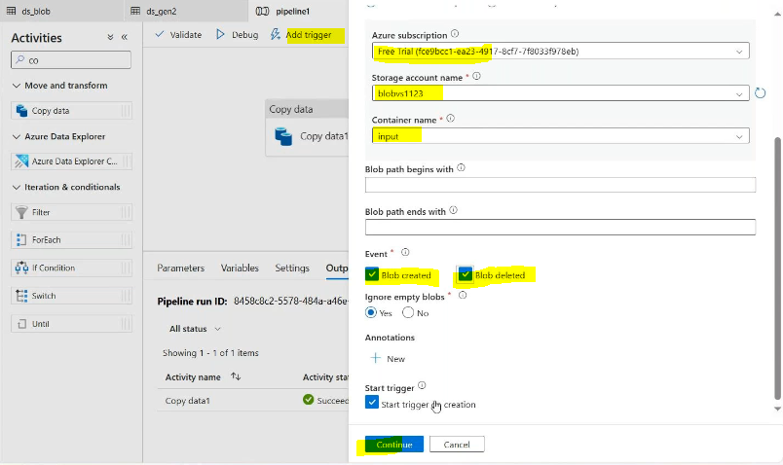
Then go to event triggers we need to start
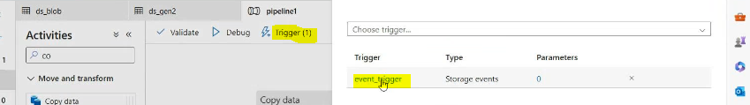
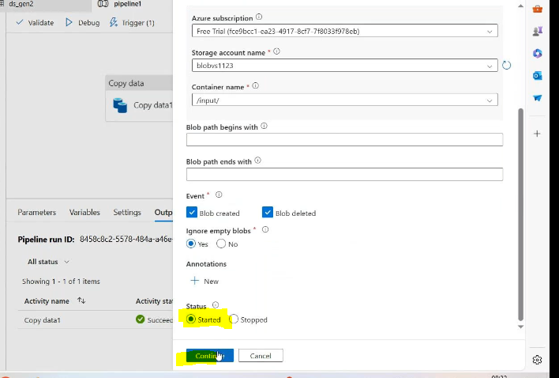
Then publish all
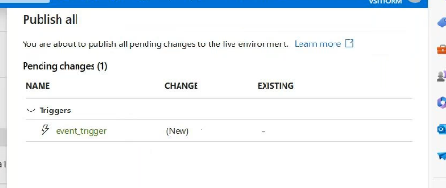

Upload any file bolb storage:
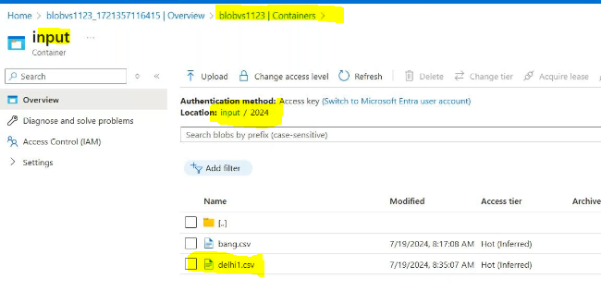
Result:
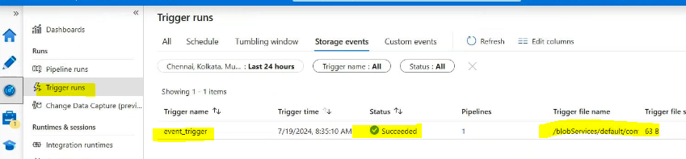
Then delete same file :
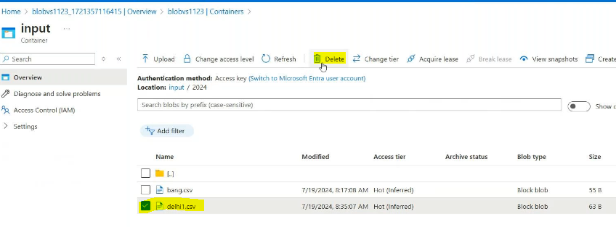
Result:
